API

*EXAMPLE 1 – WITHOUT BEARER TOKEN*

1. Download PyCharm 🡪 Create new project 🡪 <https://apipheny.io/free-api/> 🡪 Go to this site & read basic concepts.
2. View 🡪 Tool Windows 🡪 Python Packages 🡪 Install ‘requests’
3. Below is the code which doesn’t require any registration and you can directly execute and get the output (ignore header as this API is free and doesn’t require Key for authentication):

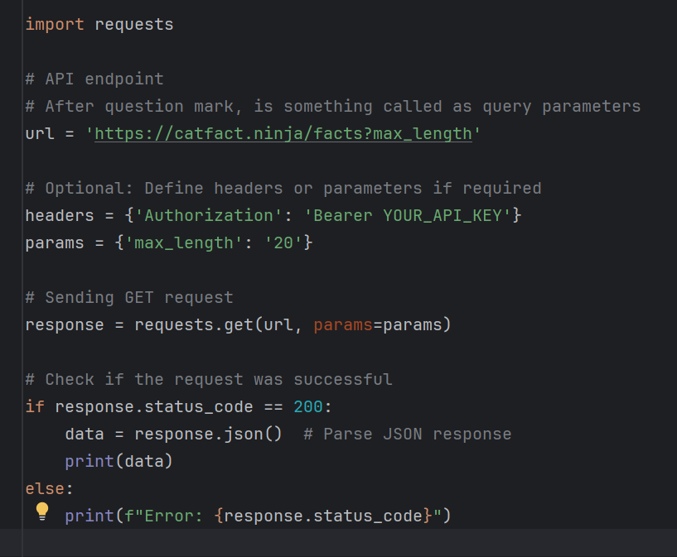

Output:

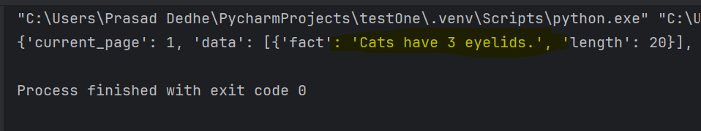

In above code in URL post ‘?’ parameters are given and each parameter in the URL will be separated by &. For example, <https://catfact.ninja/facts?max_length=20&limit=5> in case of multiple parameters. Remember you don’t have to mention the parameter is URL if you are using params as variable, like in above example the URL could have simply been <https://catfact.ninja/facts> and it would have worked just fine. I have just written for understanding purpose.

1. Sign in Postman 🡪 enter the same URL 🡪 Check output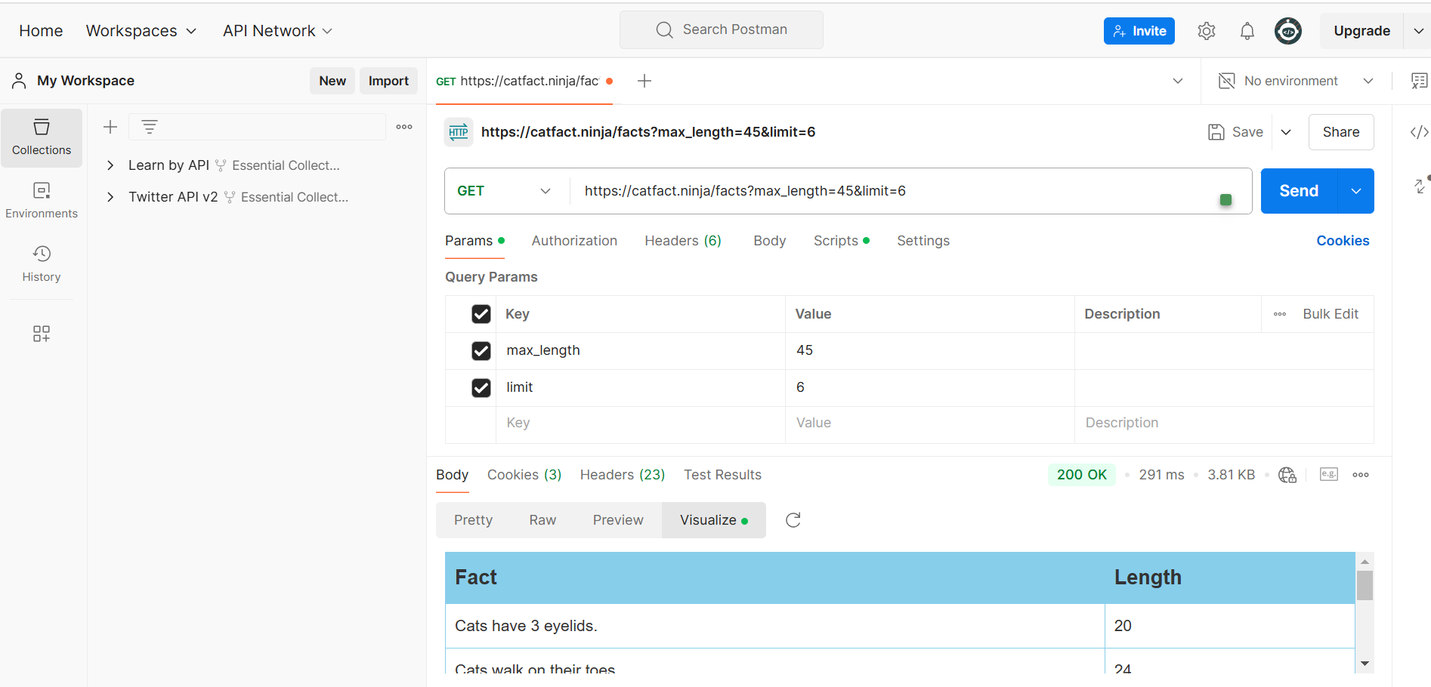
2. If you want to test, PUT, DELETE, PUT, PATCH these requests without any authentication, go to the site, <https://restful-api.dev/> and then try one by one in postman. 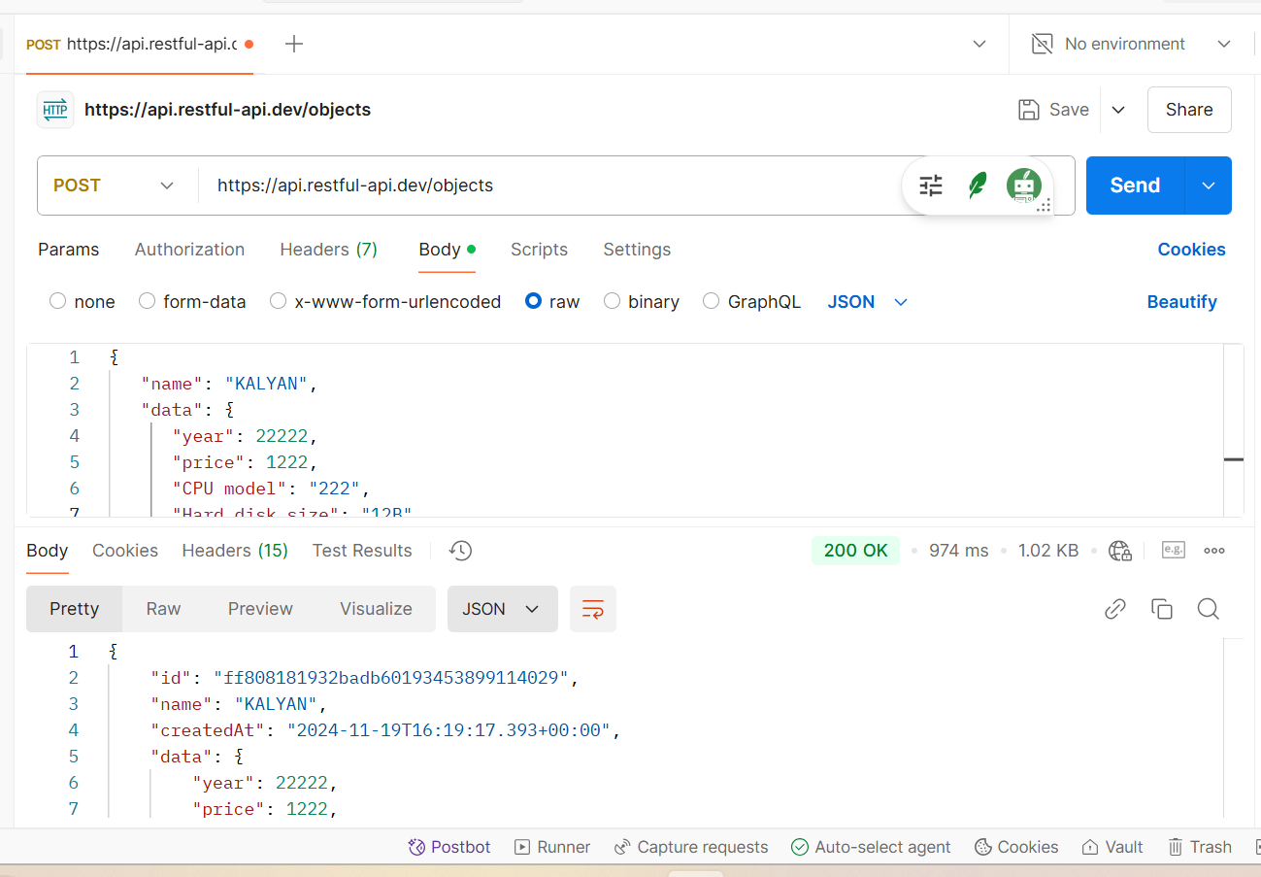
3. *EXAMPLE 2 – WITH BEARER TOKEN*
4. We will be using X (twitter) API. To get that you have to register to X developer account. Go to project 🡪 create an app 🡪 Generate Token 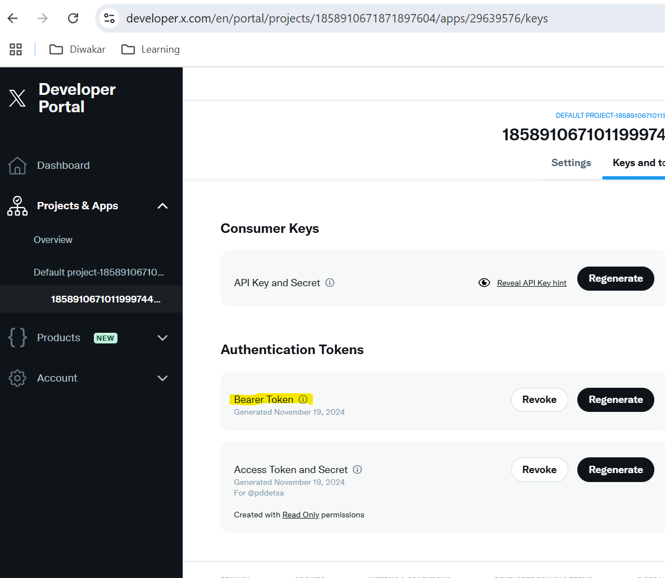
5. After that use below code where in params, you add the auth token in below format and run the code. You can find the API name and the authorisation way on X documentation and on chatGPT. This is how it will authenticate and give the data. See the code and output below. 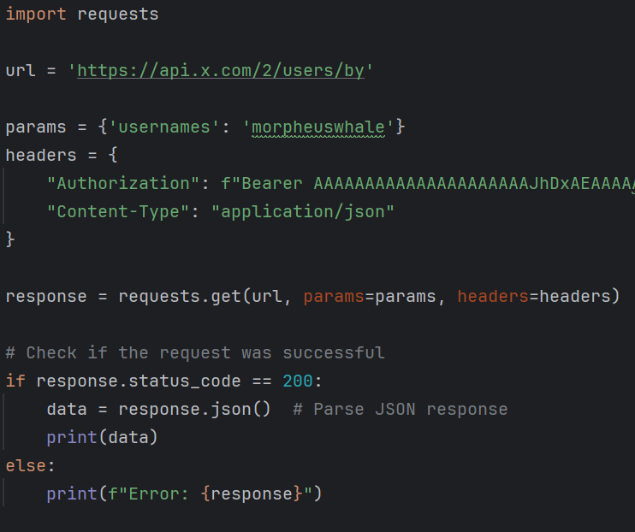 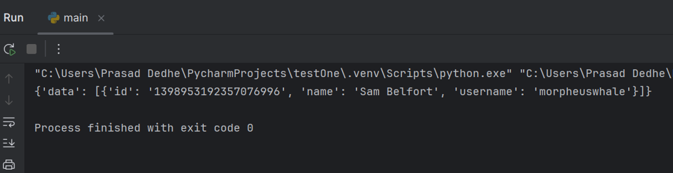
6. *EXAMPLE 3 – USING TWO APIS IN ONE CALL*
7. Type below code and execute, it will fetch the longitude and lattitude based on your IP and the provide you with the response. Always remember API is nothing but how two computer programs talk between each other. That’s the rawest defination anyone can give. 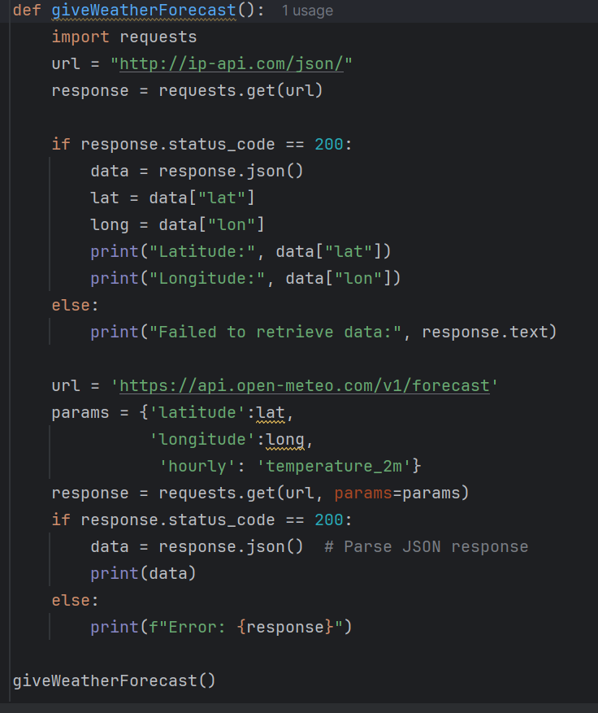 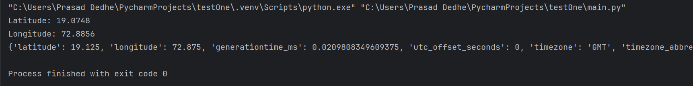
8. **How to Inspect API logs**, Inspect 🡪 Network 🡪Click on the name of API request 🡪 Headers will give you all information and payload will give you authentication token (do not share it with anyone its sensitive) 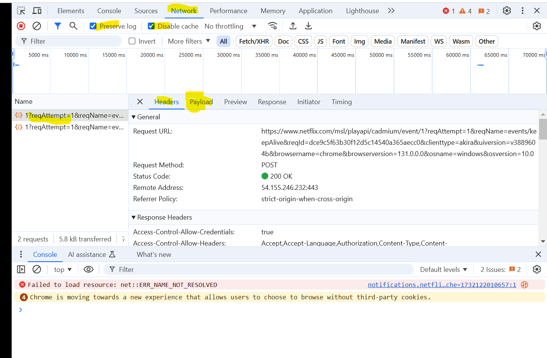
9. Final words: There are tons of different ways you can use APIs, but APIs are defined in the backend and you can use a same API URL using different methods, with different params and body. In somecases headers might also pass some parameters but I haven’t found any while creating this SOP. Also, in many cases tokens can be generated using different ways, like maybe passing API key and API secret to the OAuth sever and then it will create a token out of it.All in all I can say, APIs are simple easy to use with proper documentation.
10. URL 🡪 The URL to call API; Param 🡪 The config you put while sending URL (for example in PATCH method you pass id) ; body 🡪 the changes are to be made (for example for the same id, you send the updated data); headers 🡪 the details about the response and request (mostly auto generated by the server). That’s it. The end.